SYDNEY WESTERN CITY PLANNING PANEL

Panel No: | 2018WCI009.
DA Number: | DA/2018/1223/1.
Local Government Area: | Camden.
Development: | Staged extension of Oran Park Podium Shopping Centre. Stage 1 includes the extension of Oran Park Podium Shopping Centre retail space, construction of one residential flat building (five storeys above the retail space), construction of one commercial building (four storeys above the retail space), extension of basement car park, and extension of Main Street. Stage 2 seek concept approval (building envelopes) for two residential flat buildings fronting Central Avenue.
Street Address(es): | Lot 3 DP 270899  351 Oran Park Drive, Oran Park; and  Lot 12 DP 270899  76 Central Avenue, Oran Park
Applicant / Owner: | Perich Property Trust – C/o Urbanco
Date of DA Lodgement: | 5 November 2018
Number of Submissions: | Five submissions were received with two objecting to the proposal and three in support
Recommendation: | Approve with conditions.
Regional Development Criteria (Schedule 7 of State Environmental Planning Policy (State and Regional Development) 2011): | Development with capital investment value >$30 million.
List of All Relevant s4.15(1)(a) Matters: | - State Environmental Planning Policy (State and Regional Development) 2011.  - State Environmental Planning Policy (Sydney Region Growth Centres) 2006  - State Environmental Planning Policy No 65 – Design Quality of Residential Apartment Development.  - State Environmental Planning Policy (Infrastructure) 2007.  - State Environmental Planning Policy No 55 - Remediation of Land.  - Sydney Regional Environmental Plan No 20 - Hawkesbury-Nepean River.  - Camden Development Control Plan 2011.  - Oran Park Development Control Plan.
List all Documents Submitted with this Report for the Panel’s Consideration: | - Assessment report.  - State Environmental Planning Policy (Sydney Region Growth Centres) 2006 assessment table  - State Environmental Planning Policy No 65 – Design Quality of Residential Apartment Development assessment table  - Oran Park Development Control Plan assessment table.  - Camden Development Control Plan assessment table.  - Recommended conditions.  - Proposed plans.  - Applicant’s Clause 4.6 Request to Contravene a Development Standard.  - Collated submissions.  - Collated external referral responses.  - Site Photographs
Report Prepared By: | Clare Aslanis, Executive Planner DA Assessment – West.
Report Date: | May 2020.

Summary of Section 4.15 matters

Have all recommendations in relation to relevant s4.15 matters been summarised in the Executive Summary of the assessment report? | Yes.

Legislative Clauses Requiring Consent Authority Satisfaction

Have relevant clauses in all applicable environmental planning instruments where the consent authority must be satisfied about a particular matter been listed and relevant recommendations summarised in the Executive Summary of the assessment report? | Yes.

Clause 4.6 Contraventions to Development Standards

If a written request for a contravention to a development standard (Clause 4.6 of the Growth SEPP) has been received, has it been attached to the assessment report? | Yes.

Special Infrastructure Contributions

Does the DA require Special Infrastructure Contributions (s7.24)? | Yes.

Conditions

Have draft conditions been provided to the applicant for comment? | Yes.

PURPOSE OF REPORT

The purpose of this report is to seek the Sydney Western City Planning Panel’s (the Panel’s) determination of a development application (DA) for the Oran Park Podium extension including residential and commercial towers.

The Panel is the consent authority for this DA as the capital investment value (CIV) of the development is $91,088,316. This exceeds the CIV threshold of $30 million prescribed in Schedule 7 of State Environmental Planning Policy (State and Regional Development) 2011.

SUMMARY OF RECOMMENDATION

That the Panel determine DA/2019/1223/1 for the Oran Park Podium Shopping Centre extension including residential and commercial towers pursuant to Section 4.16 of the Environmental Planning and Assessment Act 1979 by granting consent subject to the conditions attached to this report.

EXECUTIVE SUMMARY

Council is in receipt of a DA for the Oran Park Podium Shopping Centre extension including residential and commercial towers at 351 Oran Park Drive, Oran Park.

The DA has been assessed against the Environmental Planning and Assessment Act 1979, the Environmental Planning and Assessment Regulation 2000, relevant environmental planning instruments, development control plans and policies.

A summary of the assessment of all relevant environmental planning instruments is provided below with a detailed assessment provided later in the report.

State Environmental Planning Policy (State and Regional Development) 2011. | The Panel is the consent authority for this DA as the development has a CIV of $91,088,316 which exceeds the CIV threshold of $30 million.
State Environmental Planning Policy (Sydney Region Growth Centres) 2006 | The proposal has been assessed against the provisions of the Growth Centres SEPP Appendix 1 – Oran Park and Turner Road Precinct Plan. An assessment table is attached to this report.
State Environmental Planning Policy No 65 – Design Quality of Residential Apartment Development | The residential component of the proposal has been assessed against the provisions of SEPP 65. An assessment table is attached to this report. One minor variation is addressed in the body of this report.
State Environmental Planning Policy (Infrastructure) 2007 (ISEPP). | The development is traffic generating development and referral to the Roads and Maritime Service (now known as Transport for NSW) was required. RMS comments have been received and considered.
State Environmental Planning Policy No 55 - Remediation of Land. | Council staff have assessed a preliminary site investigation (phase 1) contamination assessment submitted in support of the DA. Council staff are satisfied that the site is suitable for the development.
Sydney Regional Environmental Plan No 20 - Hawkesbury-Nepean River (SREP 20). | The development is consistent with the aim of SREP 20 (to protect the environment of the Hawkesbury-Nepean River system) and all of its planning controls.

The application was notified to surrounding properties and advertised in the local newspaper for a 30 day period between 6 November 2018 and 6 December 2018. A total of five (5) submissions were received, with three (3) in support of the proposal and two (2) objecting to the proposal.

It is noted that the originally submitted development application (DA) included a 12 storey residential tower (above podium level) that substantially breached the existing maximum height of buildings development standard. A planning proposal (PP) was lodged concurrently with the DA that sought to increase the maximum height of buildings development standard for that portion of the site on which the 12 storey residential tower was proposed. While the PP has received in principle support from Council, as well as a Gateway Determination, the applicant has chosen to remove the 12 storey residential tower from the current application to allow the DA to be determined in a timely manner.

The submissions received generally related to the scale of this portion of the development, including traffic impacts from the increased density and privacy issues from the elevated balconies.

The applicant intends on submitting a fresh DA for this residential tower following the gazettal of the planning proposal (if it is supported by Council).

Based on the assessment, it is recommended that the DA be approved subject to the conditions attached to this report.

AERIAL PHOTO

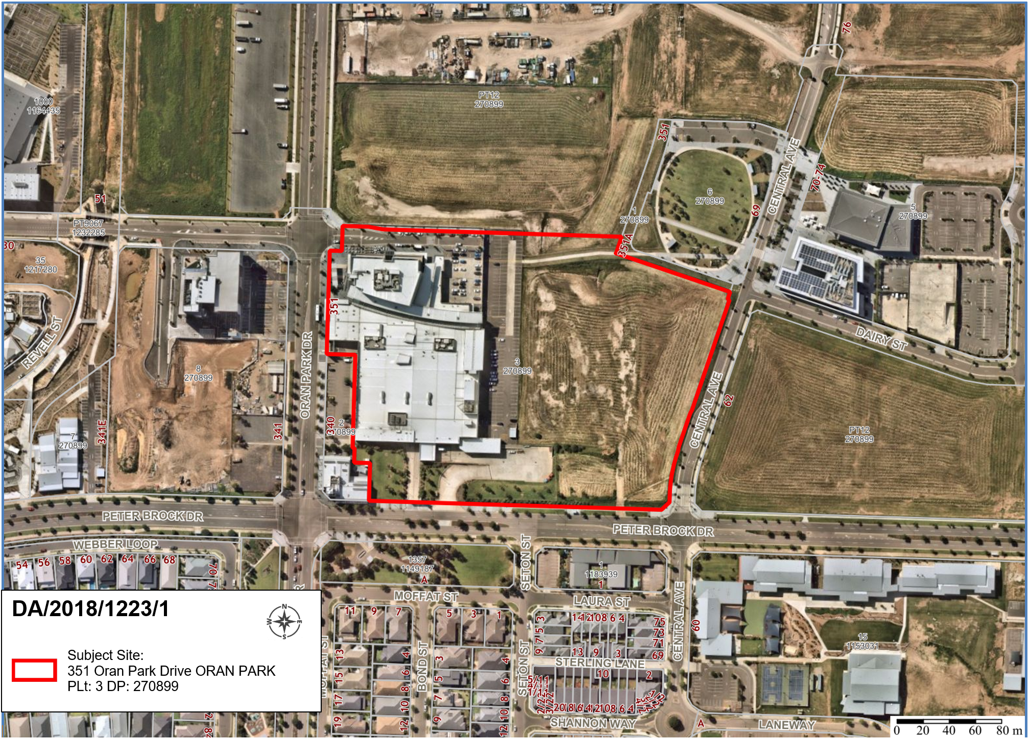
Figure 1: Aerial photograph

THE SITE

The Oran Park Podium site is located at No. 351 Oran Park Drive, Oran Park. The site is a single allotment with the legal description of Lot 3, DP 270899.The site has an area of approximately 5.53 hectares and is located within the Oran Park Town Centre.

To the north east the site directly adjoins the town park (Perich Park) with the Civic Precinct (including Council’s Administration Building and the Oran Park Library) located to the east. To the west, on the opposite side of Oran Park Drive, there is a recently completed commercial building which is six (6) storeys in height.

The site is well situated with established transport links along Oran Park Drive and Peter Brock Drive.

The site contains the existing shopping centre (i.e. Stage 1 of the Oran Park Podium) over part of the site with the majority of the site currently undeveloped. This area is envisaged to be a retail precinct within the town centre under the Indicative Layout Plan for Oran Park.

The portion of the site the subject of this DA is generally grassed and free of structures with the exception of a footpath connecting the Civic Precinct to the existing Podium Shopping Centre. The existing building contains a basement car parking area with a loading dock to Peter Brock Drive. The loading dock area slopes down from the street and is screened by landscaping to reduce any noise and visual impacts.

The surrounding area is characterised by a mix of low and medium density residential to the south, Camden Council and the Oran Park Library to the east and further commercial development clustered to the west.

A large portion of the Oran Park Town Centre is yet to be developed and currently remains vacant. In particular, areas to north and south east of the site are vacant but will ultimately contain commercial and mixed use development.

A rail corridor is also envisaged for Oran Park with the future rail station likely to be located on Oran Park Drive and within walking distance of the site.

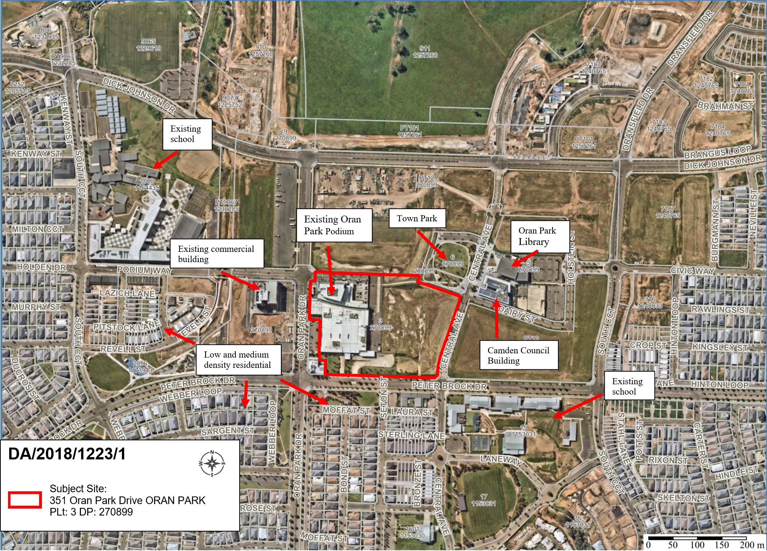
Figure 2: Site Context Plan

ZONING PLAN

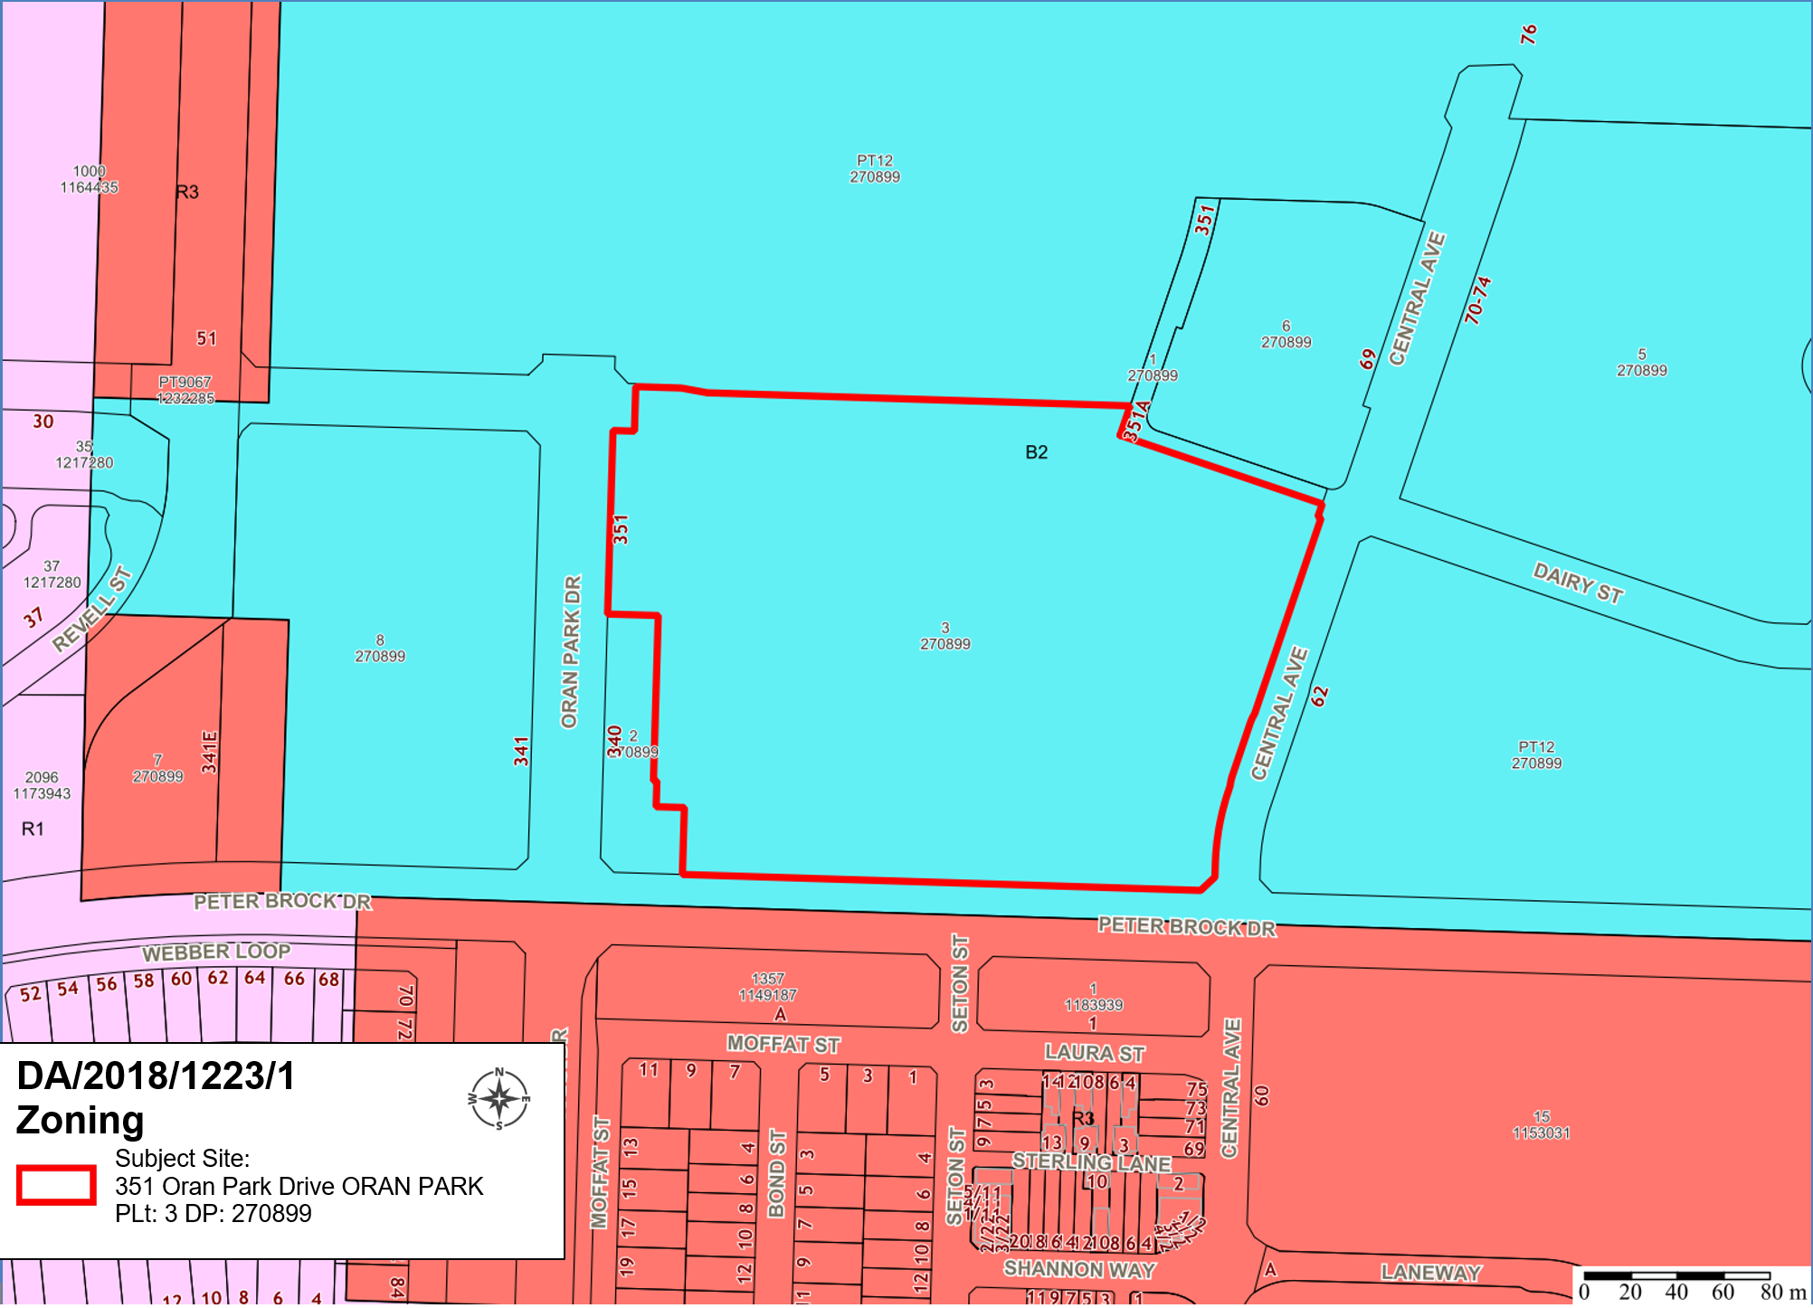
Figure 3: Site Zoning Plan

THE PROPOSAL

The subject development application (DA/2018/1223/1) seeks approved for a staged extension of Oran Park Podium Shopping Centre. Stage 1 includes the extension of Oran Park Podium Shopping Centre retail space, construction of one residential flat building (five storeys above the retail space), construction of one commercial building (four storeys above the retail space), extension of basement car park, and extension of Main Street.

Stage 2 seeks concept approval (building envelopes) for two residential flat buildings fronting Central Avenue.

Specifically the proposed development involves:

Stage 1
- Extension of the retail component to accommodate small, medium and large-scale retail uses, food hall and restaurant dining with a Gross Leasable Floor Area of 16,050m²;
  - A new Discount Department Store;
  - Two “mini-major” retail stores;
  - Speciality retail stores;
  - Food retail areas;
  - Outdoor dining / restaurant precinct along the interface with Town Park;
- Extension and minor reconfiguration of the existing basement car park to provide retail car parking areas;
- Construction of a second level basement carpark to provide parking for the proposed and future residential buildings;
- Construction of new basement car park entries along Central Avenue;
- Delivery of the eastern portion of Main Street (Podium Way) and associated landscaping along the edge of the town park;
- Construction of a five (5) storey residential flat building containing 50 dwellings above the retail complex;
- Construction of a four (4) storey commercial building containing 3,890sqm of commercial floor space above the retail complex.
- Delivery of large scale roof-top common open space and communal facilities area for the proposed and future residential apartment buildings above the retail centre; and
- Extension of the existing loading dock / service area situated along Peter Brock Drive.
- Temporary parking area as an extension of the existing basement parking along the northern edge of the car park.

Stage 2
- Two concept building envelopes for future residential buildings fronting Central Avenue.

PANEL BRIEFING

Council staff briefed the Panel on the DA on 10 December 2018. The following discussion provides an assessment of how the issues raised by the Panel at the briefing have been addressed:

- Close attention will be required to issues which will integrate the commercial and residential parts of the scheme such as the appearance of the podium rooftop from the surrounding residential towers, as well as the presentation to Main Street and the Town Park.

The proposed residential building is located in the north eastern section of the proposal with direct address to the proposed Main Street extension. The building expression draws attention to the residential entry to the building, which is separated from the public retail entry. The balconies provided for the unit directly overlook public open space and pedestrian thoroughfares for casual surveillance of these areas.

Views of the podium rooftop from the proposed residential building as well as the future / envisaged residential buildings will generally be limited to the communal open space area.

Given the size of the communal area and extensive landscape screening, the roof areas will not be visually prominent for future residents.

A recommended condition of consent requires screening of plant equipment for the benefit of future residents as well pedestrians at street level.

- Departure from the development standard for height of the residential towers by almost 100% is a significant change to the original vision for the town centre and will need strong justification, but the Panel has formed no views on that subject at this stage pending further progress of the pending planning proposal in that regard.

The twelve storey residential tower above the podium level that was previously presented to the panel as part of this proposal has since been deleted.

While the planning proposal to increase the maximum height of buildings development standard on this portion of the site has received in principle support from Council, as well as a Gateway Determination, the applicant has chosen to remove this 12 storey residential tower from the current application to allow the DA to be determined in a timely manner.

The applicant has expressed an intent on submitting a fresh DA for this residential tower following the gazettal of the planning proposal (if it is supported by Council).

It is noted that the provision of car parking, waste storage and communal open space have not been revised and are assessed as surplus to the needs of the subject proposal.

ASSESSMENT

Environmental Planning and Assessment Act 1979 - Section 4.15(1)

In determining a DA, the consent authority is to take into consideration such of the following matters as are of relevance to the development the subject of the DA:

(a)(i) the provisions of any environmental planning instrument

The environmental planning instruments that apply to the development are:

- State Environmental Planning Policy (State and Regional Development) 2011.
- State Environmental Planning Policy (Sydney Region Growth Centres) 2006.
- State Environmental Planning Policy No 65 – Design Quality of Residential Apartment Development.
- State Environmental Planning Policy (Infrastructure) 2007.
- State Environmental Planning Policy No 55 - Remediation of Land.
- Sydney Regional Environmental Plan No 20 - Hawkesbury-Nepean River.

State Environmental Planning Policy (State and Regional Development) 2011 (SRD SEPP)

The SRD SEPP identifies development that is State significant or regionally significant development.

The Panel is the consent authority for this DA as the CIV of the development is $91,088,316. This exceeds the CIV threshold of $30 million pursuant to Schedule 7 of the SRD SEPP.

State Environmental Planning Policy (Sydney Region Growth Centres) 2006

Site Zoning

The site is zoned B2 Local Centre pursuant to Clause 2.2 of the Growth Centres SEPP – Appendix 1.

Land Use Definitions

The development comprises a number of different uses, which can be defined as:
- Retail Premises
- Business Premises
- Office premises
- Shop top housing
- Residential flat building.

Permissibility

All of the above land uses are listed as permitted with consent within the B2 Local Centre zone pursuant to the land use table in the Growth Centres SEPP – Appendix 1.

Planning Controls

An assessment table in which the development is considered against the Growth Centre SEPP’s is provided as an attachment to this report.

Proposed Contravention

The applicant proposes a contravention to the height of buildings development standard that applies to the site.

The development standard limits buildings to a maximum height of 24 metres above finished ground level. The applicant proposes a maximum building height of 28 metres which equates to a 4 metre (16%) departure from the 24 metre development standard.

The contravention relates to the proposed commercial and residential towers.

Contravention Assessment

Clause 4.6(3) states that development consent must not be granted for development that contravenes a development standard unless the consent authority has considered a written request from the applicant that seeks to justify the contravention of the development standard by demonstrating:

- the applicant’s written request has adequately addressed the matters required to be demonstrated by Appendix 1, Clause 4.6(3) of the Growth SEPP, and

- the development will be in the public interest because it is consistent with the objectives of the particular standard and the objectives for development within the zones in which the development is proposed to be carried out.

In accordance with Clause 4.6(3) the applicant requests that the height of buildings development standard be varied. The applicant’s written request is attached to this report which addresses why the compliance is unreasonable and unnecessary in the particular circumstances of the case and outlines the following key environmental planning grounds to justify contravening the development standard:

- The height variation is predominantly a result of the basement excavations having already been completed under a previous consent;
- The proposal will appear to comply from street level when eventually established;
- The Town Centre is envisaged to be made up of a variety of building heights to create an interesting skyline;
- Non-compliant building heights are limited to small portions of the entire site with the proposal generally being several metres below the maximum height; and
- Non-compliant building heights are located on a part of the site that is adjacent vacant land and will not have any impact on neighboring properties.

The environmental planning grounds put forward by the applicant are supported, and compliance with the building height standard is considered to be unreasonable and unnecessary in this instance.

The development will be in the public interest because it is consistent with the objectives of the particular standard and the objectives for development within the zones in which the development is proposed to be carried out as demonstrated below:

Height of buildings development standard objectives

- To preserve the amenity of adjoining development in terms of solar access to dwellings, private open space and bulk and scale.

Comment:
The proposed residential and commercial towers are located on northern edge of the site, where adjacent sites are undeveloped. Solar access diagrams demonstrate that the buildings will not have any overshadowing issues on nearby buildings nor future buildings.

It is noted that the variation is largely a result of basement excavations having already occurred. The proposal will appear as a visually compliant building when viewed from street level.

- To provide for a range of residential building heights in appropriate locations that provide a high quality urban form.

Comment:

The subject site is located within the Oran Park Town Centre, where a variety of building forms and heights are envisaged. The proposed buildings provide additional housing choice within Oran Park in a location that is close to existing and future services and amenity including a shopping precinct, library and town park.

The residential and commercial towers are located on a portion of the site with the majority of the podium building being significantly below the maximum height. This achieves variation in the skyline and positive urban form.

- To facilitate higher density neighbourhood and town centres while minimising impacts on adjacent residential areas.

Comment:

All height non-compliances are located within the town centre and located away from height map boundaries. Surrounding development will be a similar height and an appropriate transition to lower density and lower building heights will be provided through existing and future development.

The height non-compliances are located in areas of the site that ensure there will be no additional impacts on adjacent residential areas.

- To provide appropriate height controls for commercial and industrial development.

Comment:

The proposed commercial building is appropriately designed to respond to the heights of buildings in the vicinity as well as the intent of the building height control. As noted above, the variation is a technical breach caused by the fact that the site has already been excavated to facilitate a basement. The proposal will appear as a visually compliant building when viewed from street level.

B2 Local Centre zone objectives

- To provide a range of retail, business, entertainment and community uses which serve the needs of people who live in, work in and visit the local area.

Comment:

The proposal includes a range of uses including, residential, commercial offices and various restaurant and retail tenancies. A range of services for the community are facilitated by the proposal.

- To encourage employment opportunities in accessible locations.

Comment:

The proposed development is located in the town centre adjacent to the potential future rail corridor and bus stops. This location will enable accessible employment opportunities now and in the future.

- To maximise public transport patronage and encourage walking and cycling.

Comment:

The location of the development is adjacent to public transport opportunities and walking and cycling paths.

- To ensure that residential development does not detract from the primary function of the centre being to provide for retail, business, entertainment and community uses.

Comment:

The proposed residential building is situated within the Town Centre, in an area which has been identified as accommodating higher density residential development under the DCP and master planning for the Town Centre. The delivery of the proposed development will complement the provision retail, business and entertainment uses in the ground floor of the development.

- To ensure that residential development does not preclude the provision of active uses at street level.

Comment:

The proposed apartment building delivers ground floor retail and restaurants along the street frontages to provide an activated street edge interface.

- To provide for land uses of a higher order and density within the Local Centre Zone than are permitted within the Neighbourhood Centre Zone or the Mixed-Use Zone.

Comment:

The proposed apartment building represents a higher density built form than is permitted within the Neighbourhood Centre or Mixed Use zones. The proposal also incorporates a range of services as well as a large communal open space area above the Podium Shopping Cetnre that is uniquely facilitated by this site.

- To provide for residential development that contributes to the vitality of the local centre.

Comment:

The proposal has been designed to deliver a residential apartment, retail and commercial building which enhances the vitality of the local centre. The provision of a variety of communal and private open space areas within the development reflects and contributes to this vitality.

The proposal results in a preferable outcome on the site as compared to a strictly compliant scheme. The basement car park is included within the overall building height due to the previously completed excavation works. The proposal will be consistent with other compliant built forms within the vicinity upon completion.

Consequently, it is recommended that the Panel support this proposed contravention to the maximum height of buildings development standard contained in the Growth Centres SEPP.

State Environmental Planning Policy No 65 – Design Quality of Residential Apartment Development (SEPP 65)

The application has been assessed against the provisions of SEPP 65 and the Apartment Design Guide as a mixed use development with a residential component. The proposal is generally compliant with conditions where necessary with the exception of Clause 4F-1.

An assessment table is provided as an attachment to this report.

ADG Control Variation – 4F-1 Common Circulation and Spaces Design Criteria

The control requires a maximum of eight units off a circulation core on a single level. This clause also provides that where this is not achieved, no more than 12 apartments should be provided off a circulation core on a single level.

The proposal includes 10 units off a circulation core, however, provides two lifts to each level. All circulation spaces are able to meet other length requirements as well as providing ventilation and natural light through windows.

The intent of the control is met through the quality of the circulation spaces and does not result in long corridors. The provision of a second elevator also ensures adequate reasonable amenity (i.e. wait times for lifts) for residents.

A variation to this control is considered reasonable in this instance.

State Environmental Planning Policy (Infrastructure) 2007 (ISEPP)

The ISEPP aims to facilitate the effective delivery of infrastructure across the State.

Roads and Maritime Services (RMS), now known as Transport for NSW

The DA was referred to RMS for comment pursuant to Clause 104 of the ISEPP as the development is classed as traffic generating development being that it exceeds the size or capacity specified in Schedule 3 of the ISEPP.

RMS raised no objection to the development.

State Environmental Planning Policy No 55 - Remediation of Land (SEPP 55)

SEPP 55 provides a State-wide planning approach to the remediation of contaminated land.

Clause 7 of SEPP 55 requires the consent authority to consider if the site if contaminated. If the site is contaminated, the consent authority must be satisfied that it is suitable in its contaminated state for the development. If the site requires remediation, the consent authority must be satisfied that it will be remediated before the land is used for the development. Furthermore, the consent authority must consider a preliminary contamination investigation in certain circumstances.

The applicant has submitted a preliminary site investigation (phase 1) in support of the DA. This assessment found the site to be suitable for the development from a contamination perspective. Council staff have reviewed the assessment, agree with the findings and are satisfied that the site is suitable for the development.

A standard unexpected finds contingency condition is recommended that requires any contamination found during construction to be managed in accordance with Council's Management of Contaminated Lands policy.

Sydney Regional Environmental Plan No 20 - Hawkesbury-Nepean River (SREP 20)

SREP 20 aims to protect the environment of the Hawkesbury-Nepean River system by ensuring that the impacts of future land uses are considered in a regional context.

The development is consistent with the aim of SREP 20 and all of its planning controls. There will be no detrimental impacts upon the Hawkesbury-Nepean River system as a result of the development. Appropriate erosion, sediment and water pollution control measures have been proposed as part of the development.

(a)(ii) the provisions of any proposed instrument that is or has been the subject of public consultation under this Act and that has been notified to the consent authority (unless the Secretary has notified the consent authority that the making of the proposed instrument has been deferred indefinitely or has not been approved)

Draft Environment State Environmental Planning Policy (Draft Environment SEPP)

The development is consistent with the Draft Environment SEPP in that there will be no detrimental impacts upon the Hawkesbury-Nepean River system as a result of it.

(a)(iii) the provisions of any development control plan

Oran Park Development Control Plan

An assessment table in which the development is assessed against the Oran Park DCP is provided as an attachment to this report.

The two (2) variations identified in the assessment table are addressed below:

DCP Control Variation No 1 – 7.3 Building Envelopes / Bulk and Scale

The building height for the Stage 2 concept building envelopes are shown up to the 24 metre maximum height of building development standard. As such it is likely that any future building contained within this envelope will vary from the four (4) floor maximum height identified in the DCP’s Figure 69A.

Furthermore the proposed commercial and residential towers are four and five storeys above podium level, therefore also varying from the four (4) and five (5) floor maximum height identified in the DCP’s Figure 69A.

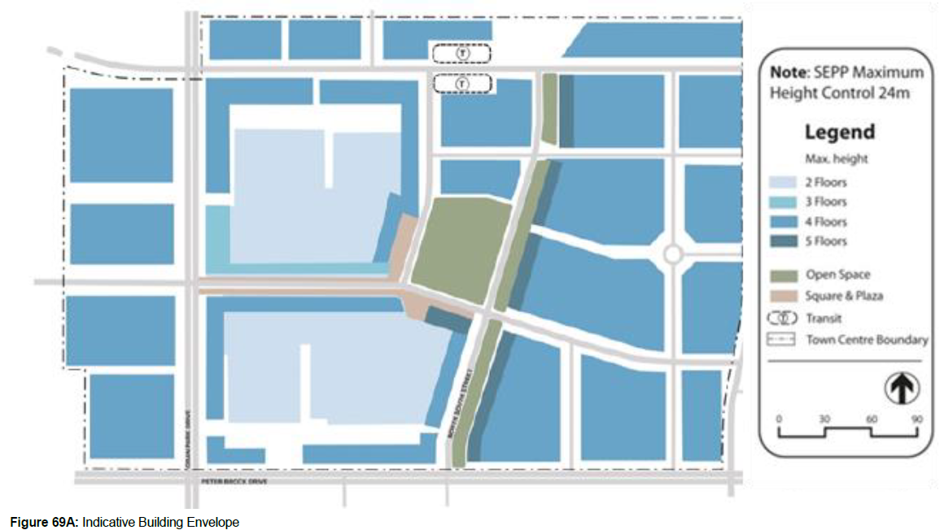

This is consistent with the application of the maximum building heights across Oran Park. As the currently proposed and future buildings are able to comply with the maximum height of building development standard (albeit the subject application is supported by a Clause 4.6 submission caused by a technical variation to the maximum height of building development standard) it is considered reasonable for this DCP control to be varied.

The above Indicative Building Envelope plan aims to ensure that building heights are varied across the town centre and an interesting skyline is achieved. It is noted that the built form across the site is predominantly less than the two storey maximum with taller commercial and residential towers in different locations above the podium level. The variation of building heights across the site ensures that an interesting skyline and positive urban design outcome is achieved.

The proposed building envelopes contribute to the varying building heights for the town centre within the confines of the development standards and zone objectives.

Proposed Variation No. 2 – 6.0 Environmentally Sustainable Development Principles - Green Star Rating

The applicant has not submitted certification that the building’s design has reached a minimum 4 Green Star rating from the Green Council of Australia. The applicant has also indicated they are unwilling to accept the requirement to obtain this certification for the Green Council of Australia as part of the conditions of consent.

To assess sustainability outcomes, the proponent has adopted the site-specific sustainability criteria which were prepared for ‘Attachment B’ in the DCP in consultation with the Department of Planning, Landcom, Camden Council and the Oran Park Town project team. The sustainability controls are considered more appropriate to the Western Sydney context of the subject site than adopting a standardized target of the 4 Star Green Star rating.

A detailed Environmental Sustainability Development Report has been prepared which demonstrates that the proposed building either meets, or exceeds all of the sustainability measures and criteria listed in the Sustainability DCP which forms Attachment B. The report also addresses compliance with Section J of the BCA, which sets out a range of measures that requires buildings to be constructed to reduce greenhouse gas emissions.

The report meets the objectives and intent of the sustainability measures of the Part B DCP, being to ensure the new commercial building achieves an appropriate level of environmentally sustainable design.

Requiring strict compliance with the private Green Star system is not considered warranted in this circumstance. All buildings delivered within the Oran Park Town Centre to date have successfully adopted and implemented the Part B DCP Sustainability Measures.

Consequently, it is recommended that the Panel support these two proposed variations to the Oran Park DCP 2007.

Camden Development Control Plan 2011 (Camden DCP)

The proposal was notified and advertised in the local newspaper in accordance with the provisions of the Camden DCP.

(a)(iiia) the provisions of any planning agreement that has been entered into under section 7.4, or any draft planning agreement that a developer has offered to enter into under section 7.4

The site falls within land which is subject to the Oran Park Urban Release Area Voluntary Planning Agreement (VPA), signed in September 2011.

The Oran Park VPA provides for infrastructure and associated facilities within the Oran Park Town project, in lieu of payments under the Oran Park & Turner Road Precinct Contributions Plan.

The site is located within Stage G, as identified in the VPA. A number of facilities are required to be delivered prior to progression of the overall Oran Park precinct development. The application has been referred to Council’s Contributions Team, who have indicated that all relevant deliverables in Stage G have been completed and raise no objection to the application subject to the recommended conditions of consent.

(a)(iv) the regulations (to the extent that they prescribe matters for the purposes of this paragraph)

The Environmental Planning and Assessment Regulation 2000 prescribes several matters that are addressed in the conditions attached to this report.

(b) the likely impacts of the development, including environmental impacts on both the natural and built environments, and social and economic impacts in the locality

As demonstrated by the assessment, the development is unlikely to have any unreasonable adverse impacts on either the natural or built environments, or the social and economic conditions in the locality.

Traffic Impacts
Oran Park is a master planned site and the local road network has been designed and constructed to cater for the delivery of the proposed land use. A traffic report was prepared for the proposal which concludes that the traffic impacts resulting from the proposal are acceptable and within the limits of the existing street network.

The application was also referred to the RMS as Traffic Generating Development. The RMS raised no objection with no specific conditions recommended.

Parking impacts
The proposal provides 1,399 car parking spaces for the entire development. The car parking provided exceeds the minimum required under the Camden Development Control Plan with a large portion of the surplus located in the residential parking area. This is the result of planned future residential buildings in this location and the desire of the applicant to avoid future retro fitting of the car parking areas. Surplus car parking spaces are proposed to be temporarily used for the commercial building tenants. All users of this car parking area will require security pass access and will only be able to park in designated spaces. A recommended condition of consent will ensure that only residents of residential building and tenants of the commercial building have secure access until such time as the future residential developments are established and those spaces are required for the future buildings.

It is noted that the temporary car parking area on the northern side of Main Street contains an additional 126 car parking spaces. These spaces will be used for construction vehicles as well as overflow for the Podium Shopping Centre until such time as 76 Central Avenue is developed.

Noise impacts
The proposal has been assessed against the relevant noise criteria and no concerns are raised with regard to the noise generated by the proposal. The more intense land uses and street activation occurs at the northern end of the site where there is less residential density existing and envisaged. This limits the potential nuisance caused by noise from the retail and restaurant users.

The loading dock area at the southern end of the site has been assessed for noise impacts on nearby residents. The slope of the site results in the loading and servicing area being below street level with the addition of a landscape buffer located on the property boundary to mitigate noise leaving the site.

An assessment has also been undertaken to ensure that communal open space, private open space/balconies and internal noise levels for the proposed residential component of the development are all acceptable. That assessment confirms that noise levels to all components of the proposed residential development are acceptable and the proposal maintains adequate levels of amenity.

Visual impacts
The proposal has incorporated a number of architectural features to appropriately break up the large building masses through articulation, landscaping and building materials. The variation in building heights across the site contributes to the breaking up of masses and improved visual interest.

The building design and scale are an appropriate urban design outcome for the Oran Park Town Centre with surrounding buildings providing a transition to lower and medium density residential developments. All ground floor tenancies provide human scale through awning heights, street tree plantings and footpath widths to ensure that the development is inviting and visually unobtrusive.

(c) the suitability of the site for the development

As demonstrated by the above assessment, the site is considered to be suitable for the development.

(d) any submissions made in accordance with this Act or the regulations

The application was notified to surrounding properties and advertised in the local newspaper for a 30 day period between 6 November 2018 and 6 December 2018. A total of five (5) submissions were received, with three (3) in support of the proposal and two (2) objecting to the proposal.

As mentioned above, the originally submitted DA included a 12 storey residential tower (above podium level) that substantially breached the existing maximum height of buildings development standard. The objections received generally related to the scale of this portion of the development, including traffic impacts from the increased density and privacy issues from the elevated balconies. As this previously proposed 12 storey residential tower is no longer proposed as part of the subject application, these objections are no longer relevant to the assessment of the amended proposal.

The Camden Development Control Plan requires a development to be re-notified where the impacts of the development will be increased. In this case, the impacts of the proposal are decreased with the removal of the residential tower and therefore additional notification/advertising was not warranted. However, given the changes to the application all those who made submissions were informed of the amendments and Council’s decision to not renotify. No further responses were received following this correspondence being sent out.

(e) the public interest

The public interest is served through the detailed assessment of this DA under the Environmental Planning and Assessment Act 1979, the Environmental Planning and Assessment Regulation 2000, environmental planning instruments, development control plans and policies. Based on the above assessment, the development is consistent with the public interest.

EXTERNAL REFERRALS

The external referrals undertaken for this DA are summarised in the following table:

External Referral | Response
Roads and Maritime Services (RMS) (now known as Transport for NSW) | No objections raised.
NSW Police – Camden Local Area Command | No objections raised, subject to recommended conditions of consent.
Endeavour Energy | No objections raised, subject to recommended conditions of consent.
Sydney Water | No objections raised, subject to recommended conditions of consent.
Camden Airport | No objections raised.

Conditions that require compliance with the above recommendations are included in the recommended conditions of consent.

FINANCIAL IMPLICATIONS

This matter has no direct financial implications for Council.

CONCLUSION

The DA has been assessed in accordance with Section 4.15(1) of the Environmental Planning and Assessment Act 1979 and all relevant instruments, plans and policies. The DA is recommended for approval subject to the conditions attached to this report.

RECOMMENDED
That the Panel:
- Support the written request lodged pursuant to Clause 4.6 of State Environmental Planning Policy (Sydney Region Growth Centres) 2006 to contravene the maximum height of buildings development standard, and

- Approve DA/2018/1223/1 for the Oran Park Podium extension including residential and commercial towers at 351 Oran Park Drive, Oran Park subject to the conditions attached to this report.

